|  |  |
| --- | --- |
| **CL2001**  **Data Structures Lab** | **Lab 03**  **Linked list and types of linked list** |

**NATIONAL UNIVERSITY OF COMPUTER AND EMERGING SCIENCES**

**Fall 2025**

# Lab Content

1. Linked List
2. Singly Linked List
3. Doubly Linked List
4. Circular Linked List

# Linked List

Like arrays, Linked List is a linear data structure. Unlike arrays, linked list elements are not stored at a contiguous location; the elements are linked using pointers.

A singly linked list is indeed a type of linked list where each element (node) consists of two parts:

* Data: This part of the node holds the actual value or data that you want to store in the list. It can be any data type, such as integers, characters, or custom data structures.
* 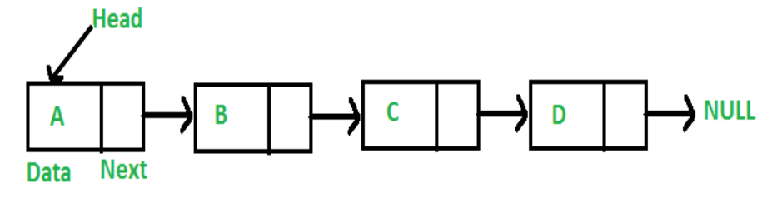Pointer to the Next Node: This part of the node contains a reference or pointer to the next node in the list. This pointer helps maintain the structure of the linked list and allows you to traverse the list in a unidirectional manner, usually from the head (the first node) to the last node. The last node typically points to NULL to indicate the end of the list.

# Creating a Linked List: Node and Singly Class

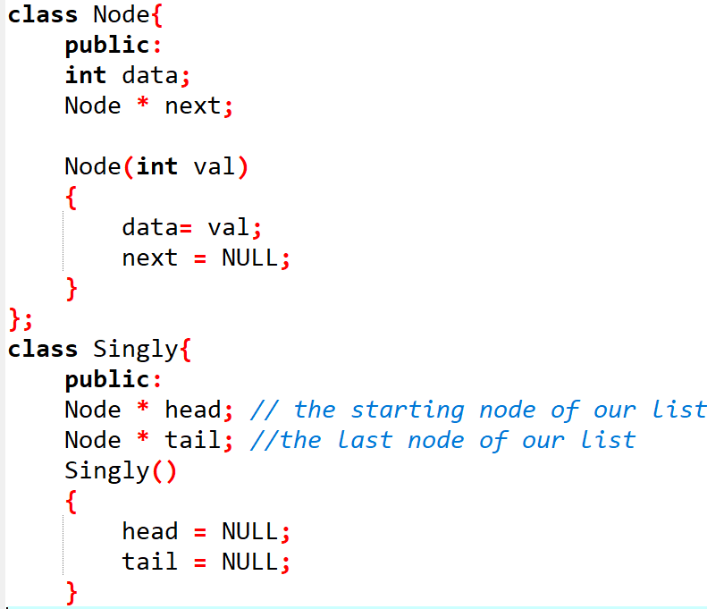

**Adding Node to Linked List(Front,End and anywhere)**

Adding a node to a linked list involves inserting an element, which consists of data and a reference to the next node, either at the front (beginning), the end (tail), or at any specified position within the list.

**InsertionAtTail: Append**

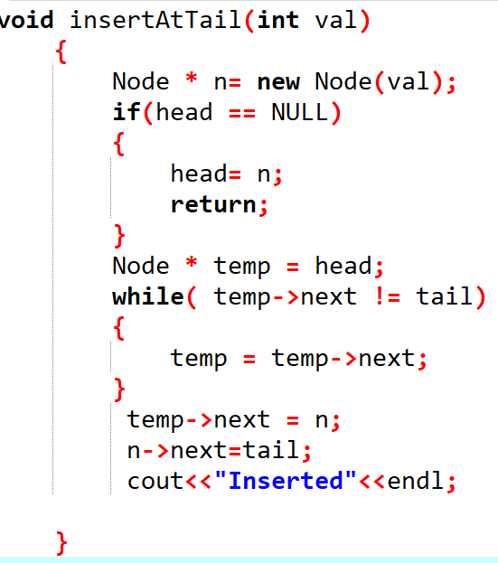

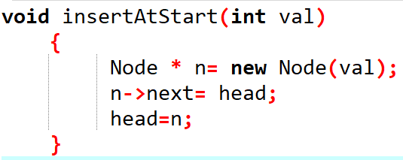**InsertionAtStart: Append**

**InsertAfter/Insert at any Position**

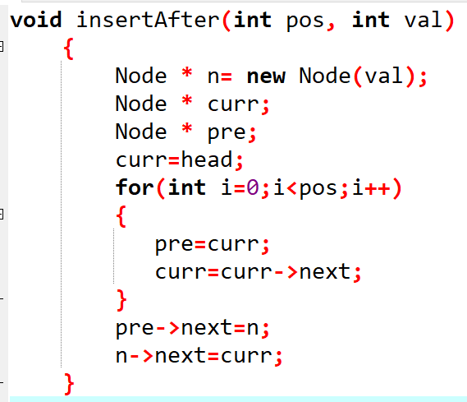

**Searching for a Key**

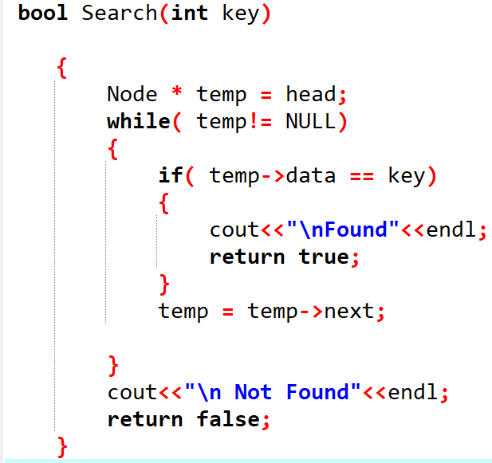

**Displaying the Linked List/Traversal**

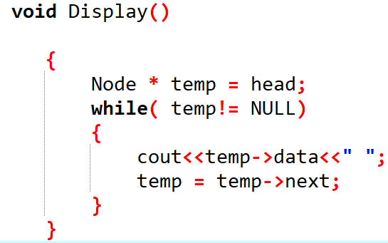

**Removal of Nodes: Deletion**

Performing a deletion operation on a linked list involves removing an element, either from the front (beginning), the end (tail), or from any specified position within the list, effectively altering the list's structure

**DeletionFromEnd**

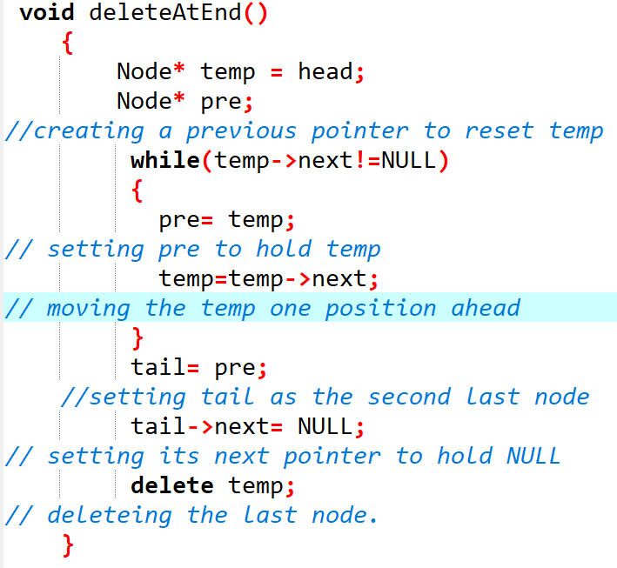

**DeletionFromStart**

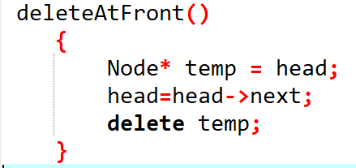

**DeleteAfter/ Delete at any position**

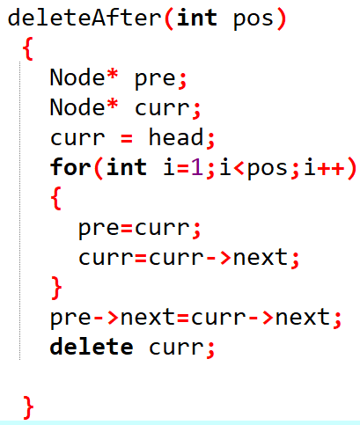

**Doubly Linked List:**

A Doubly Linked List is a linear data structure similar to a singly linked list, but with an important difference: each node in a doubly linked list contains two pointers instead of one. It has a pointer to the next node as well as a pointer to the previous node. This bidirectional connectivity allows traversal in both forward and backward directions.

**Creation of Doubly Linked List**

class Node {

public:

int data;

Node* next;

Node* prev;

Node() : data(0), next(NULL), prev(NULL) {}

Node(int val) : data(val), next(NULL), prev(NULL) {}

};

class DoublyLinkedList {

public:

Node* head;

Node* tail;

DoublyLinkedList() : head(NULL), tail(NULL) {}

void insertAtEnd(int val) {

Node* newNode = new Node(val);

if (tail == nullptr) {

head = newNode;

tail = newNode;

} else {

tail->next = newNode;

newNode->prev = tail;

tail = newNode;

}

}

};

**Circular Linked List and Helper Functions:**

A Circular Linked List is a data structure in which elements, known as nodes, are connected in a circular fashion. Unlike a regular singly linked list, where the last node points to null, in a circular linked list, the last node points back to the first node, creating a loop.

Here's a list of common helper functions that are often implemented in a Circular Linked List:

Append: Add a new node to the end of the circular linked list.

Insert: Add a new node at a specific position in the circular linked list.

Delete: Remove a node with a given value from the circular linked list.

Search: Find a node with a specific value in the circular linked list.

Display: Print the elements of the circular linked list.

Reverse: Reverse the order of nodes in the circular linked list.

**Creation of Circular Linked List**

